**LEBANESE AMERICAN UNIVERSITY**

**USAID – HIGHER EDUCATION SCHOLARSHIP PROGRAM**

**HES - Volunteering Program Verification Form**

This form is to be used to document volunteering hours. If a student volunteers for multiple organizations, a separate form must be used for each organization. **This form must be turned in by the 28th of each month, the latest.**

I certify that the scholar Lara Tabaja completed a total of 15 hours of service at InnovaThrive.

The hours were completed hours as per the below:

Hours # 5 (date) _2/12 – 6/12_ (initials of supervisor) __A.K.___

Hours # 5 (date) _9/12 – 13/12_ (initials of supervisor) __A.K.___

Hours # 5 date) _16/12 – 20/12 (initials of supervisor) __A.K.___

Hours # 0 date) _23/12 - 27/12 (initials of supervisor) __A.K.___

Brief description of the activities the scholar performed or participated in:

1) Research 1: The Ethics of Predictive Policing Using AI  
Definition: Examining the ethical dilemmas surrounding AI-driven law enforcement.  
Technologies:  
  
Machine learning models for crime prediction.  
  
Natural language processing for threat analysis.  
Applications:  
  
Predictive deployment of law enforcement resources.  
  
Identifying potential threats through social media monitoring.  
Statistics: Studies showing mixed success in reducing crime rates via predictive policing.  
Advantages:  
  
Proactive crime prevention strategies.  
Disadvantages:  
  
Risks of racial profiling and privacy invasion.  
Challenges:  
  
Ensuring transparency in algorithmic decision-making.  
Future Research:  
  
Developing AI models with built-in ethical safeguards.  
  
Analyzing the societal impacts of predictive policing.  
  
2) Research 2: AI in Enhancing Urban Air Quality Monitoring  
Definition: Investigating AI’s role in tracking and improving air quality in cities.  
Technologies:  
  
IoT-enabled air quality sensors.  
  
Machine learning models for pollution pattern analysis.  
Applications:  
  
Dynamic adjustment of traffic to reduce emissions.  
  
Real-time public notifications on air quality levels.  
Statistics: AI systems showing 20% improvement in predicting pollution peaks.  
Advantages:  
  
Improved health outcomes for urban residents.  
Disadvantages:  
  
Costs of deploying IoT infrastructure in dense cities.  
Challenges:  
  
Integrating AI systems with government environmental policies.  
Future Research:  
  
AI for predicting long-term environmental impacts of urbanization.  
  
Collaborations between governments and AI companies for greener cities.  
  
3) Research 3: The Role of Blockchain in Transparent Humanitarian Aid Distribution  
Definition: Using blockchain to ensure accountability in disaster relief efforts.  
Technologies:  
  
Smart contracts for fund allocation.  
  
Blockchain for tracking resource distribution.  
Applications:  
  
Verifying donor contributions are used as intended.  
  
Tracking shipments of medical supplies and food.  
Statistics: Reduction in fraud by 35% in blockchain-enabled aid programs.  
Advantages:  
  
Increased trust among donors and recipients.  
Disadvantages:  
  
Technical barriers for small-scale NGOs.  
Challenges:  
  
Achieving scalability for international disaster relief efforts.  
Future Research:  
  
Integrating blockchain with AI for real-time monitoring.  
  
Expanding blockchain adoption in remote regions.

Written feedback about the scholar’s performance:

Lara’s work reflects versatility, critical analysis, and strong ethical reasoning, showcasing her capacity to handle diverse and complex topics with precision.

Please rate the overall performance of the scholar at your organization:

|  |  |  |  |
| --- | --- | --- | --- |
|  | Mastery (5) | Proficient (3) | Emerging (1) |
| **Problem solver** | X |  |  |
| **Engaged & Committed** | X |  |  |
| **Open-minded & multicultural** | X |  |  |

Signature

& stamp

__________________________

_

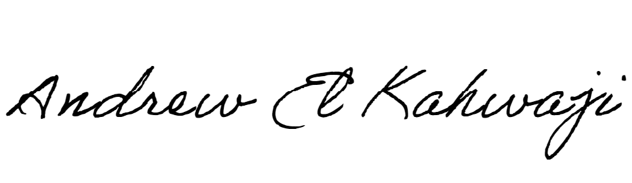

Printed Name _Andrew El Kahwaji_

Date __26/12/2024___

Email __andrew.lifesculptor.coo@gmail.com __

Phone __+961 71 914 378__